Tutorial 2 : Incorporating the river network into a catchment model
The second tutorial incorporates most of the river network. The river model of Mike She is handled by the Mike11 software package.

1. Starting MIKE SHE
- Start Mike She usig exactly the same procedure as in the previous workshop. Open the model ‘model01’ created in the previous workshop
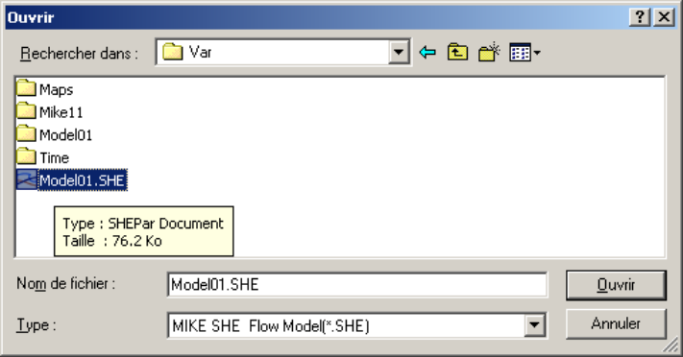
- Save it as ‘model02’
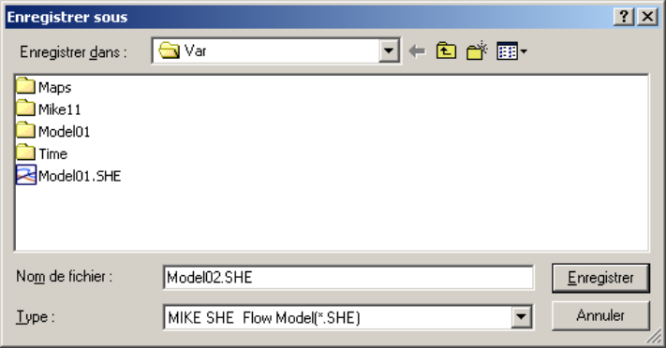

2. Specifying the river model
- Go to the ‘Simulation specification’ menu. Activate the field ‘Rivers and lakes (OC)’. This triggers the appearance of a new menu (‘Rivers and lakes’).
- Click the menu ‘Rivers and lakes’. You are being asked for the Mike11 simulation file that contains the description and simulation parameters of the river network. Select the model ‘Var01.sim11’ in the folder ‘Mike11’.
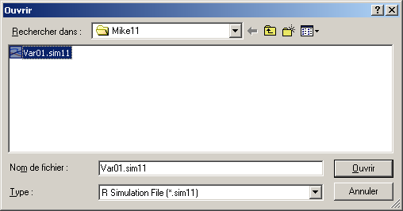
- Do not forget to save the Mike She model.

3. Activating the Mike She/Mike 11 coupling in the river model
- Open the Mike11 simulation file ‘Var01.sim11’. Open the network data file (in this particular case, ‘Var01.nwk11’)
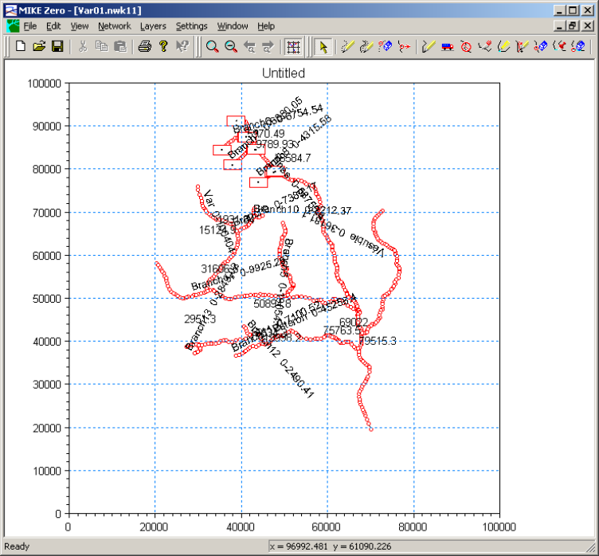
- Activate ‘View/Tabular view’ and expand the ‘Runoff/groundwater links’ menu. Click the ‘Mike She links’ menu. The following interface is displayed.
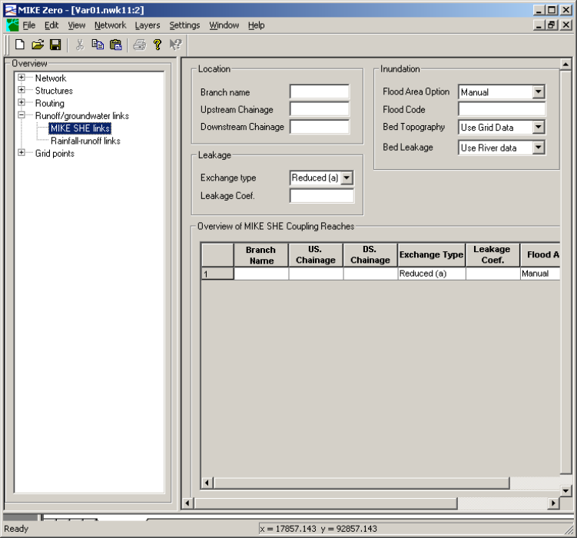
- You should now specify all the branches of the Mike11 river model that you want to interact with the Mike She model. Since the purpose of this exercise is to have full coupling between the whole river model and the Mike She model, it is sufficient to click the button ‘Include all Branches’. The data is copied from the ‘Network/Branches’ menu.
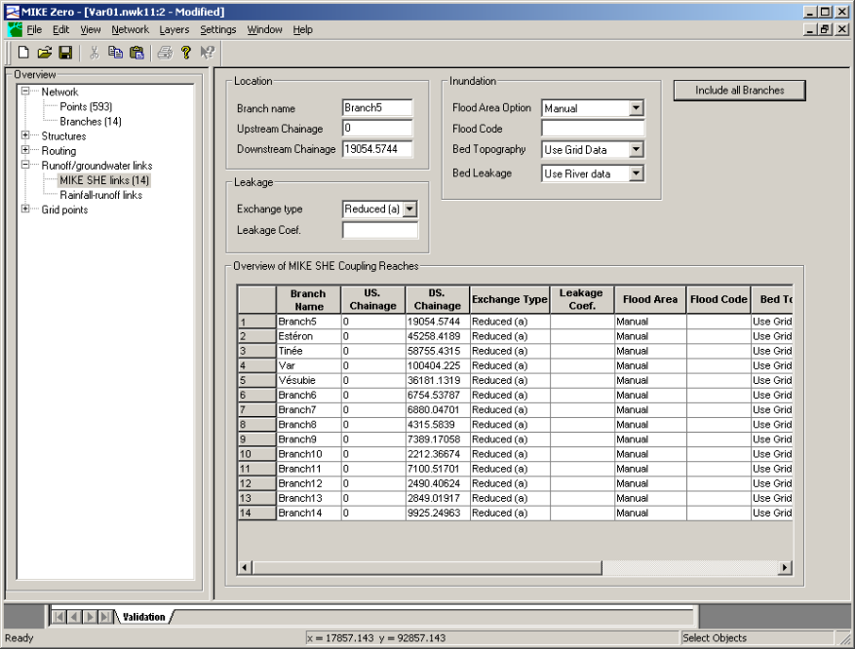
- For all branches, set the flooding option to ‘No flooding’.

4. Assignment
- Define the river longitudinal profiles and cross-sections from the DEM;
- Increase the number of computational points in the Mike11 model (Δx_{max} = 500 m at most).
- Run the new Mike She model. Carry out a sensitivity analysis on the physical and numerical parameters and on the river geometry.

